<https://financesonline.com/top-5-project-management-software-small-business-2017/>

<https://www.fastcompany.com/34070/merrill-lynch-works-home>

<https://cyber.harvard.edu/fallsem98/final_papers/Carpenter.html>

Common elements: Inbox, Stream (for latest activity update, recent events, announcements, public posts), Dashboard showing bulleted to-do lists (“bulletin”) for the day/priority tasks, message boards/forums where one can raise concern about a particular topic and others can join/respond in the thread, color coded files/shared folders, tasks are categorized by sprint/project (task lists), Gantt Views , Dispatch Portal , Work Plan, reporting tools, automated transcribing of highlights of meetings, timesheet with stopwatch timer, chatrooms, forums / feed, scrum boards showing sprints & target MVP, automate redundant tasks, issue management/conflict resolution/debug board, voip, helpdesk thats invisible for customers,time tracking,

Future plans:

Integrated virtual queueing app, community involvement notifier, personal life planner, Citizen’s desk Rescuer app

Automated event plotting in personal Gantt - with option to view workplace team Gantt

What personal Gantt checkbox includes:

1. Work - when tasks related to work are assigned/joined by an employee, the task is automatically plotted on the Gantt
2. Family - the employee manually plots a family-related event on the Gantt OR a family member may have access to manually plot events on employees Gantt under this category
3. Community - notify employee when there are upcoming recreational events/volunteering opportunities that are nearby (like sa fb) and be able to see who the other people are who RSVP’d in the same event/s; when employee clicks Join - the event is automatically plotted on employees Gantt
4. Self - employee manually plots personal errands on the Gantt

Like in gcal, one can choose which categories will be plotted at a time. In our app, after choosing which categories are plotted at a time (which ones are visible), the employee can save that setting and forward the calendar for syncing to whoever they want to give access to

Sa gcal kasi, kita lahat ng ipa-plot if you forward it to somebody. Sa atin, we can choose which categories lang we want them to have access to

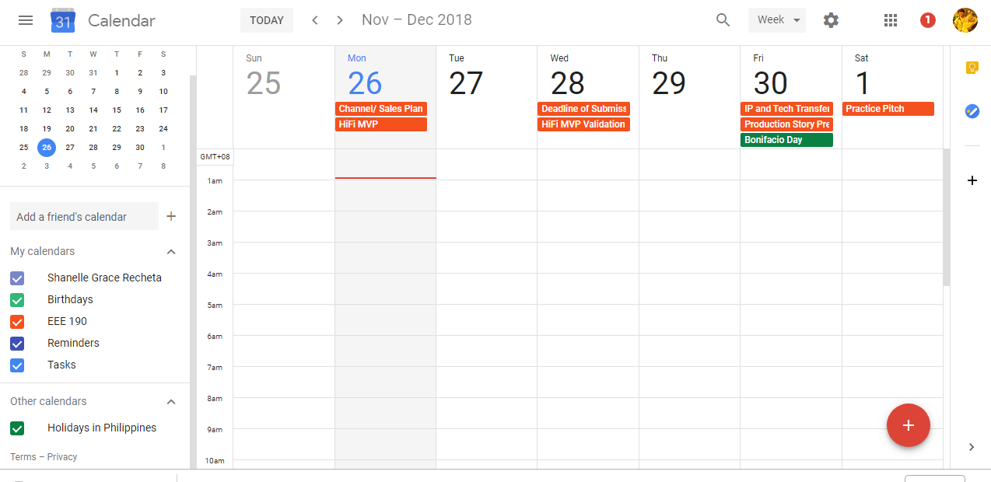

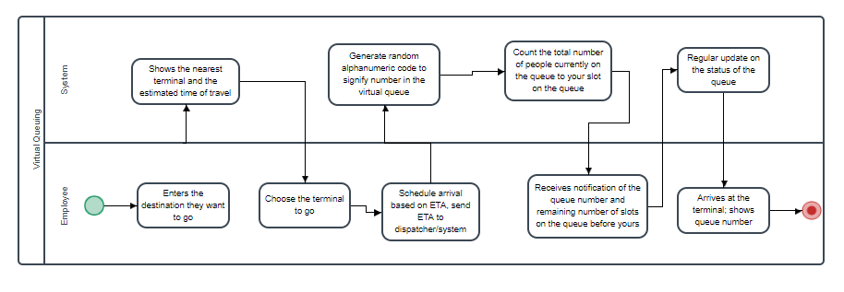

automated transcribing of highlights of meetings

* Could be a unique feature to us - an audio recorder like in soundcloud where anyone can transcribe a highlight on a specific time elapsed of the audio recording then anyone can comment on that transcription segment in real time (for those working remotely, a mechanism similar to fb live)

game-like structure

* tasks - treated like levels - can only be accessed one at a time as a current task moves from backlog to validated (tasks are locked until priority cards are accomplished)
* Employees have stats (can increase/decrease like health/damage points in a game but relates to their actual performance/efficiency)
* TPR is partly affected by the employee’s community involvement rating
* Employees belong in

Compromise between expected timeline set by employer (usu. minimum) and estimated timeline of employee (usu. maximum) for the accomplishment of a task

* Get the average of both - could mean strategizing on both sides (employer setting way below minimum and employee setting way above max)
* Get industry average for a task
* Poker Planning

1)Wrike

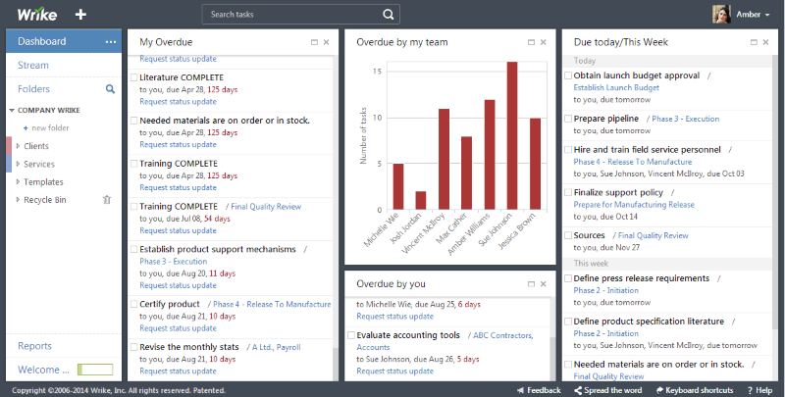

2) Asana

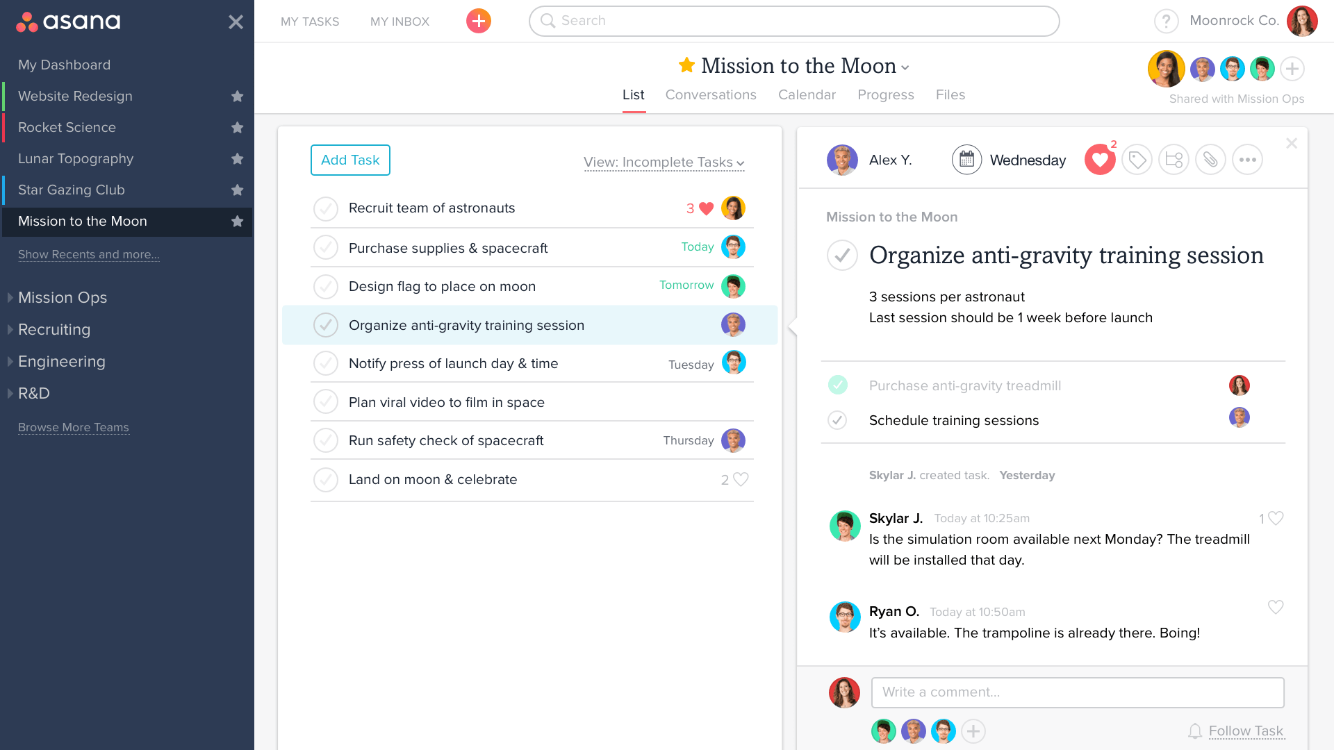

3) Monday.com - for team management - organizes tasks for the team

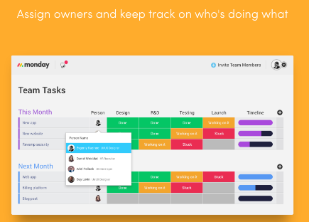

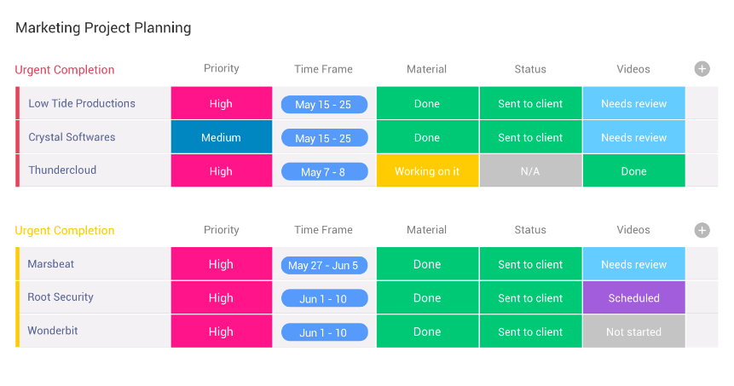

4) Basecamp - organizes all related stuff (docs and notes and threads) in one place

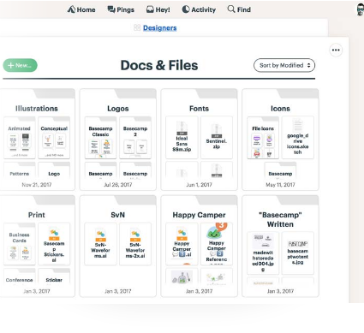

5) ConnectWise - has a Dispatch Portal that shows the dibs of tasks

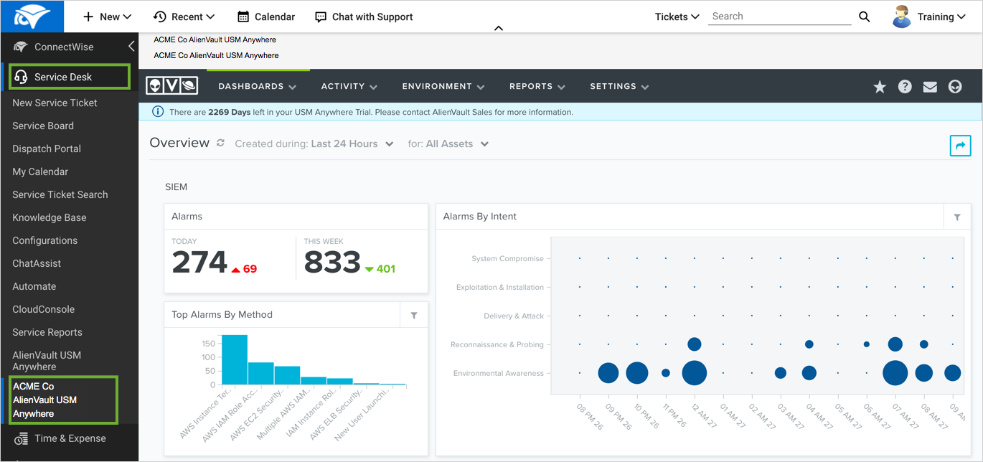

6) FunctionFox - stopwatch timer for in progress tasks

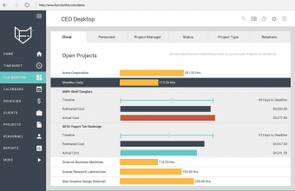

7) Quire - provides structured organizer to add actionable tasks to accomplish - provides a UI where one can place detailed & strctured list of subtasks

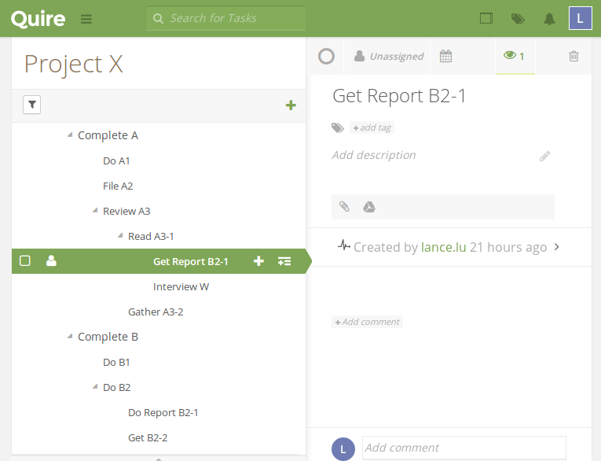

8) ravetree - shows the start and due (time tracking of a work item)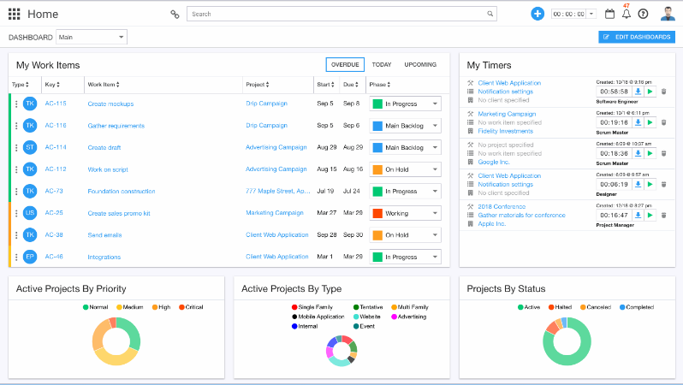

9)10,000 feet - shows team gantt chart using color coding

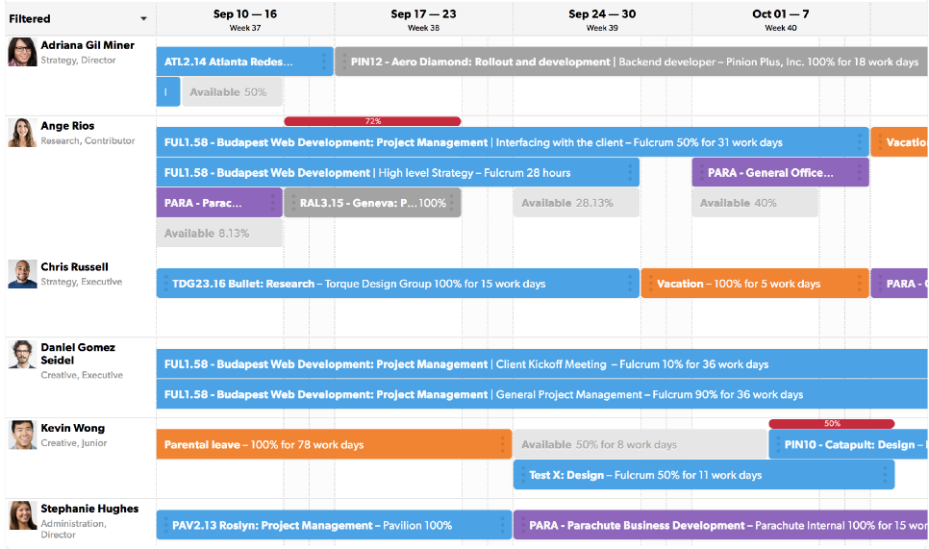

10) Paymo

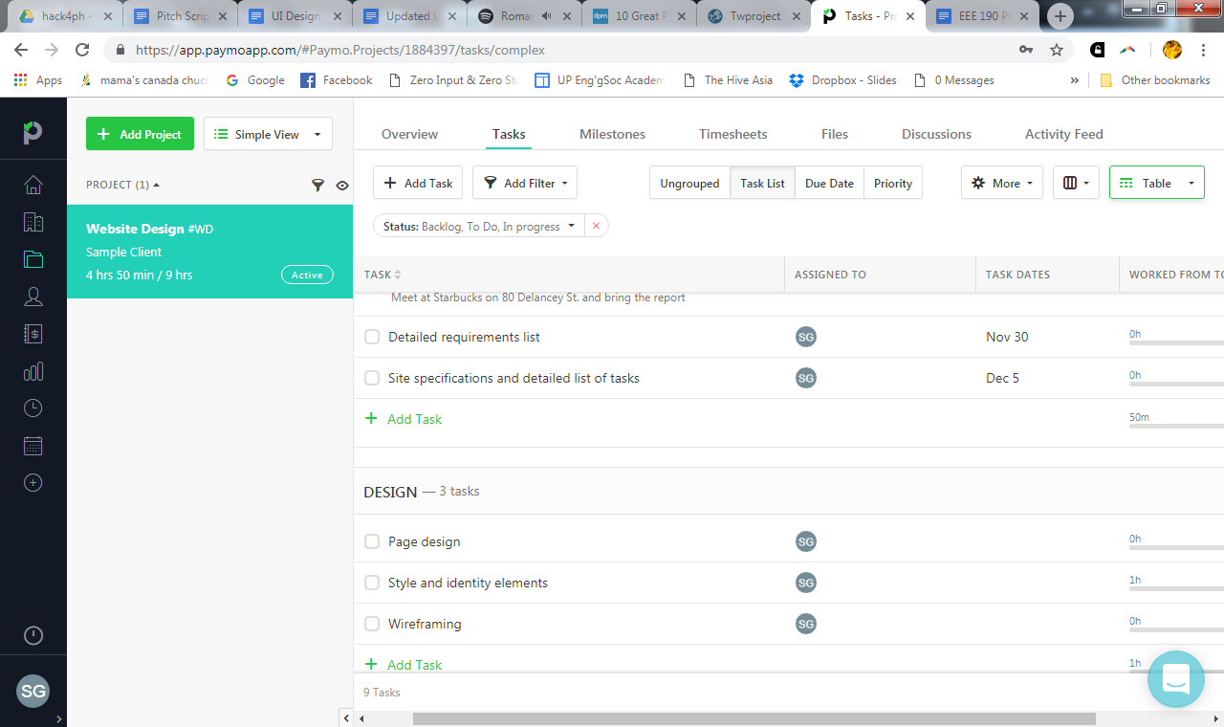

11) Twproject - sobrang comprehensive

